Assignment 15

CREATE TABLE Doctor(doc_id INT PRIMARY KEY,doc_name VARCHAR2(40),patient_id INT,discharged VARCHAR(3));

INSERT INTO DOCTOR VALUES(1,'Harsha',10,'Yes');

INSERT INTO DOCTOR VALUES(2,'vishal',11,'NO');

INSERT INTO DOCTOR VALUES(3,'abhilaash',12,'Yes');

INSERT INTO DOCTOR VALUES(4,'Kewin',13,'NO');

INSERT INTO DOCTOR VALUES(5,'Mann',14,'Yes');

SELECT *FROM DOCTOR ORDER BY DOC_ID;

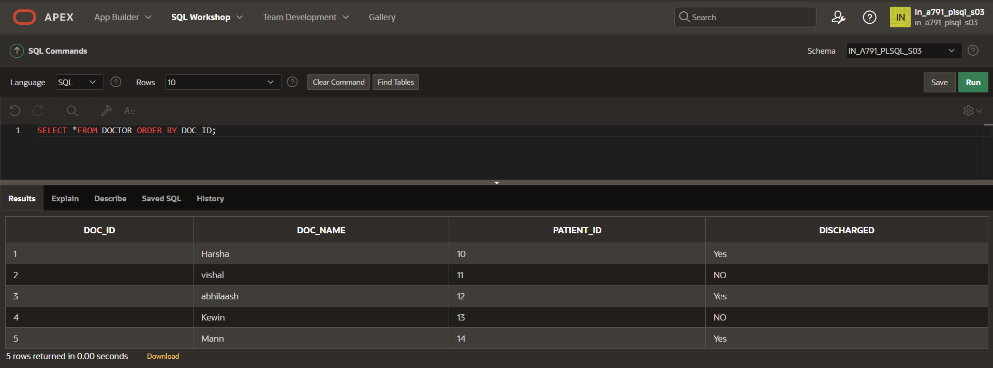

CREATE TABLE hospital(patient_id INT PRIMARY KEY,patient_name VARCHAR2(20),status VARCHAR2(20)), TREATMENT VARCHAR2(20) ;

INSERT INTO HOSPITAL (PATIENT_ID,PATIENT_NAME) VALUES (10,'Dhilip');

INSERT INTO HOSPITAL (PATIENT_ID,PATIENT_NAME) VALUES (11,'Vinoth');

INSERT INTO HOSPITAL (PATIENT_ID,PATIENT_NAME) VALUES (12,'Vasanth');

INSERT INTO HOSPITAL (PATIENT_ID,PATIENT_NAME) VALUES (13,'Murali');

INSERT INTO HOSPITAL (PATIENT_ID,PATIENT_NAME) VALUES (14,'Shaam');

SELECT *FROM HOSPITAL ORDER BY PATIENT_ID;

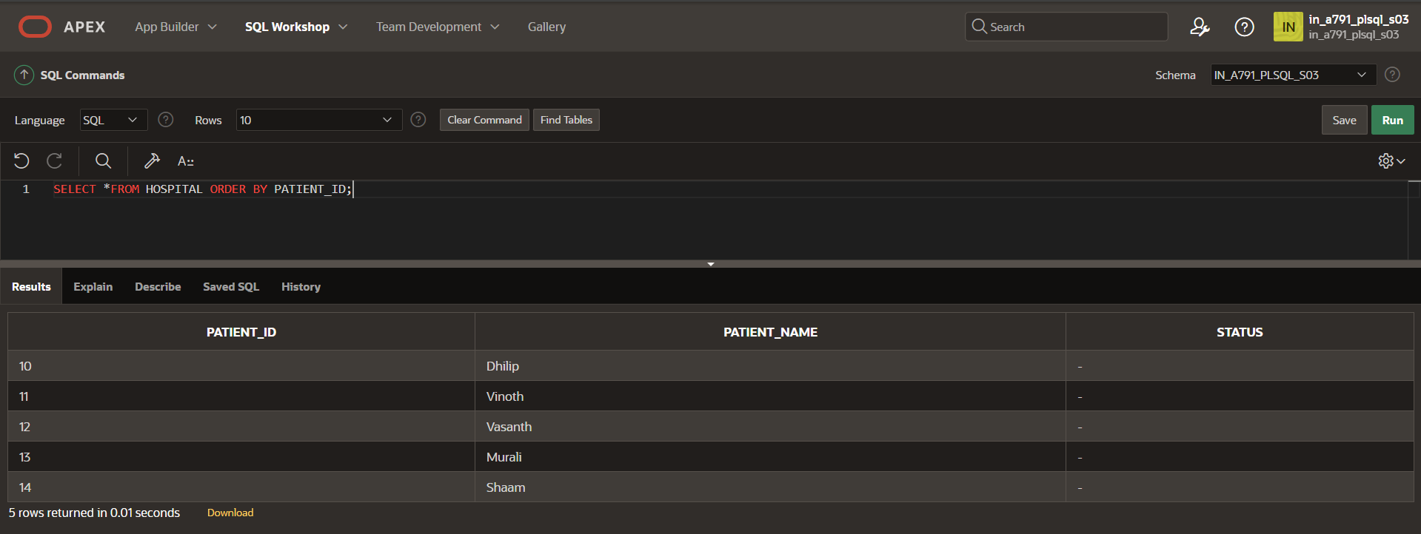

**DECLARE**

**CURSOR s1 IS**

**SELECT patient_id, discharged**

**FROM doctor;**

**v_patient_id hospital.patient_id%TYPE;**

**v_discharged Doctor.discharged%TYPE;**

**BEGIN**

**OPEN s1;**

**LOOP**

**FETCH s1 INTO v_patient_id, v_discharged;**

**EXIT WHEN s1%NOTFOUND;**

**IF v_discharged = 'Yes' THEN**

**UPDATE hospital**

**SET status = 'Discharged'**

**WHERE patient_id = v_patient_id;**

**UPDATE hospital**

**SET TREATMENT = 'Completed'**

**WHERE patient_id = v_patient_id;**

**ELSE**

**UPDATE hospital**

**SET status = 'Admitted'**

**WHERE patient_id = v_patient_id;**

**UPDATE hospital**

**SET TREATMENT = 'Going on'**

**WHERE patient_id = v_patient_id;**

**END IF;**

**END LOOP;**

**CLOSE s1;**

**END;**

**/**

**SELECT *FROM HOSPITAL ORDER BY PATIENT_ID;**

